Jennifer Sevan

Valentine Scherer

Michael Hemingway

**CART 360 - Assignment “This”**

Oct. 19th, 2018 - Extended Oct 26th 2018

GitHub

[GitHub Project](https://github.com/jsevan/CART360/tree/master/Assignment_THIS)

## Part 1: Sensor Research and Documentation

### Pressure Sensor - SPX3058D

The SPX3058D is a pressure sensor made by Motorola. I can be used with the Arduino Uno. The sensor can measure pressure and vacuum, both up to 500 mbar differential pressure.

**Voltage** 0V - 5V DC

**Input offset Voltage** 22mV

**Pressure range** -500 mbar to +500 mbar (-50kPa to +50kPa)

**Temporal-spatial requirements**

The sensor can only work with air pressure. It is possible it can work with the change of temperature.

**Pin Placement**

Pin 1 = Ground

Pin 2 = bridge Vout +

Pin 3 = +5V

Pin 4 = bridge Vout -

The sensor will be using the analog input at full range (0-5V) when connected to the Arduino at 5V. Calculations must be made for the pressure in kPa by the difference between the analog signals.  
**References:**

“Pressure Sensor with Bridge Output.” Arduino Playground - SPX3058D, playground.arduino.cc/Main/SPX3058D#Measurements.pdf

“Miele Washer ‘Check Inlet’ Flashing - Simple Repair SPX3058D Pressure Sensor.” EBay, [www.ebay.co.uk/itm/Miele-Washer-check-inlet-flashing-simple-repair-SPX3058D-pressure-sensor-/192510029705](http://www.ebay.co.uk/itm/Miele-Washer-check-inlet-flashing-simple-repair-SPX3058D-pressure-sensor-/192510029705).

**Dust/Particulate Sensor: HPMA115S0 Particle Sensor**

Laser-based sensor: via light particle scattering.

**Overview** 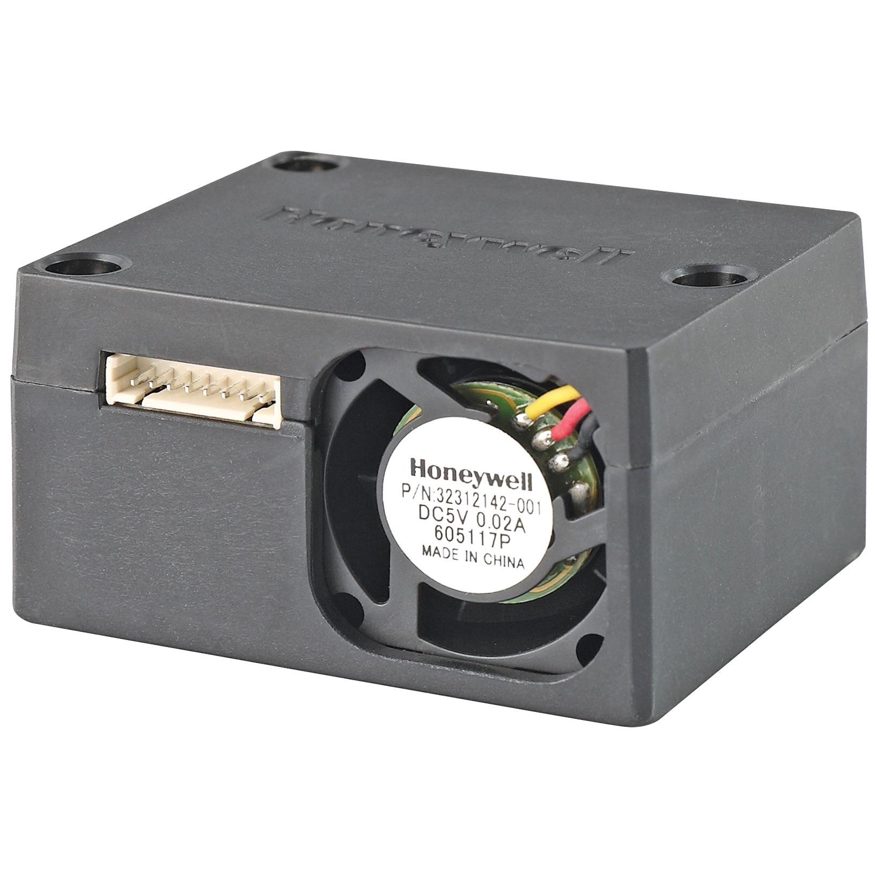

Light Particle scattering counts and measures particle concentration ranging from 0 μg/m3 to 1,000 μg/m by shining a light in a given area. As the particles darken the light beam from the lazer and acts as a shadow, a recording is made by the sensor. A conversion occurs with the light recording via a photodetector after the given light source is analyzed and converted to electrical signal that will calculate the concentration (this conversion specific to this sensor makes it advantageous compared to other particle sensors). It has < 6 seconds response and can be continuously used for 20,000 hours. It uses a UART interface. A UART is “Universal Asynchronous Receiver/Transmitter” which is circuitry in a microcontroller that enables serial communication (to send and receive serial data). Detection occurs either in PM2.5 or PM10 which refers to particulate matter that is 2.5 micrometers or less, and 10 micrometers or less. 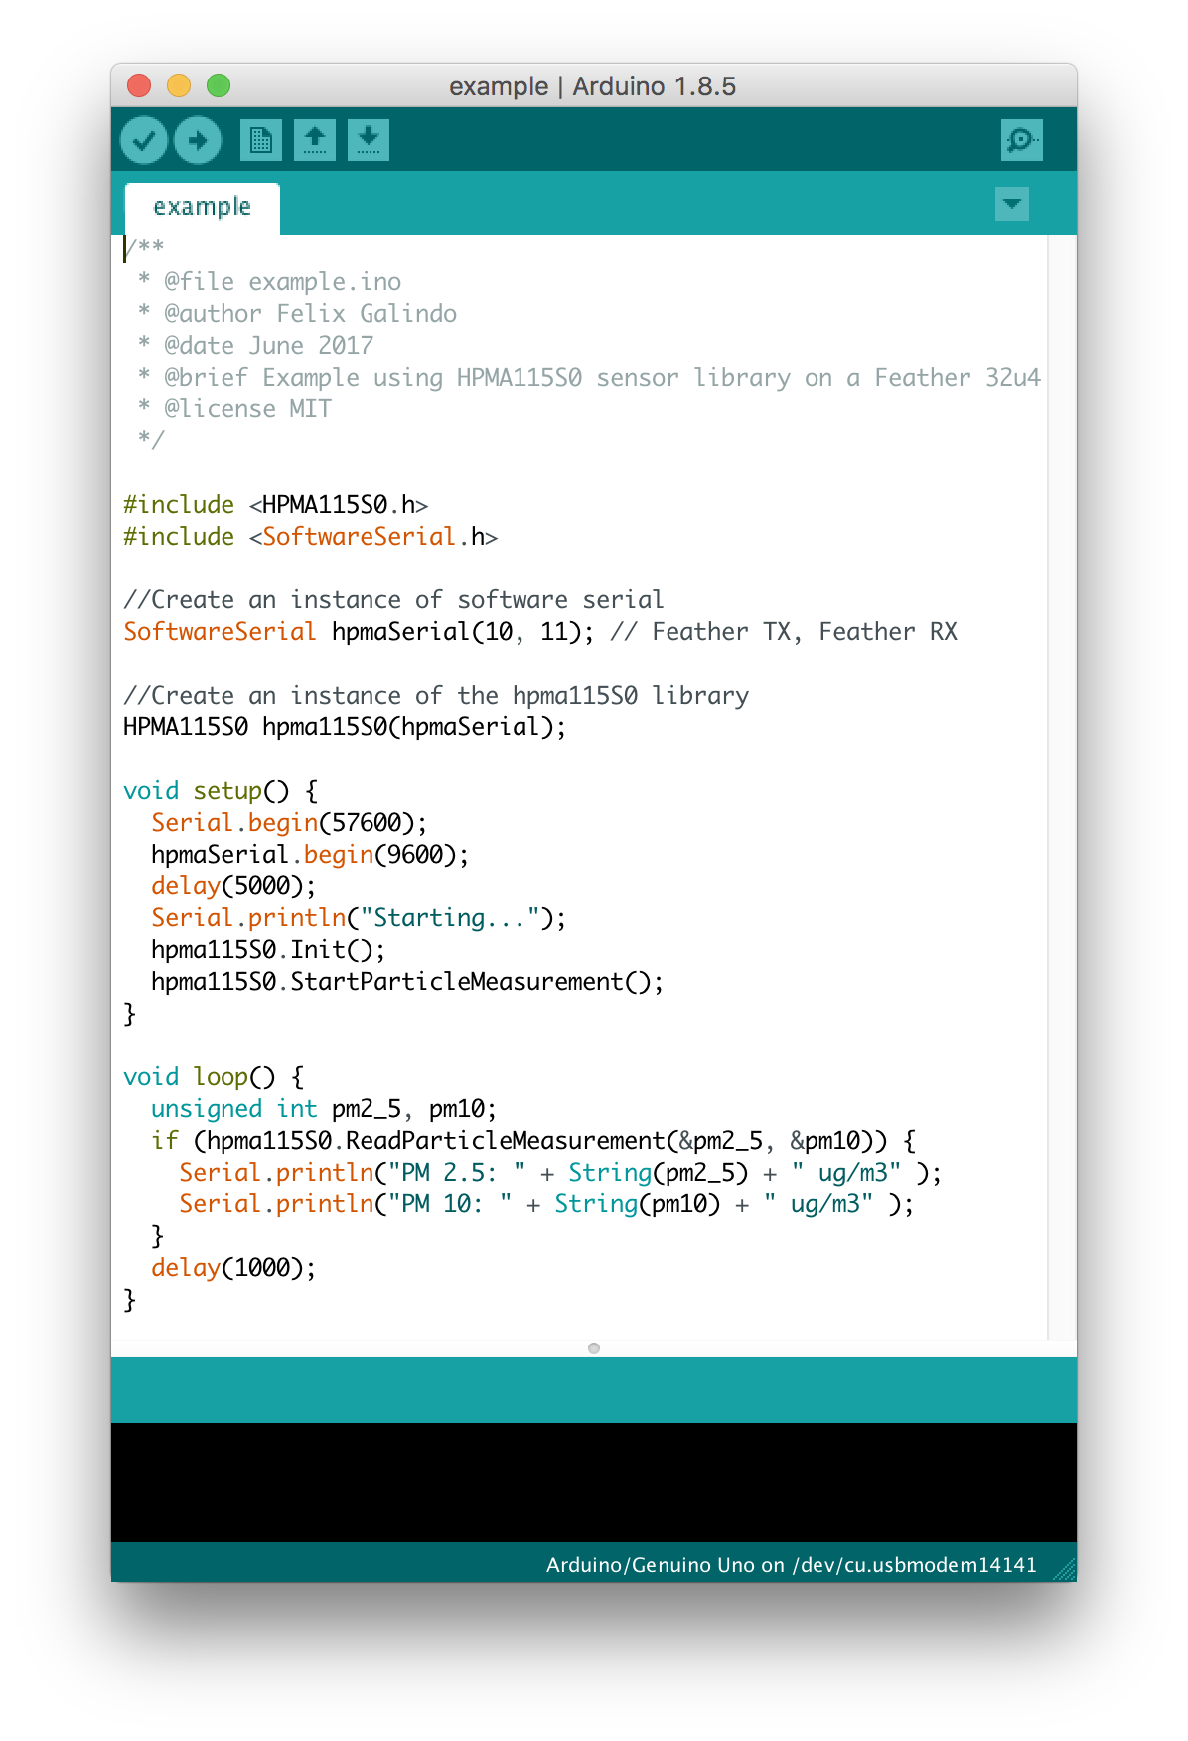

**Voltage**

5V (±0.2V) of which attributes 3.3V output to UART pins

Import and use [felix/galindo](https://github.com/felixgalindo/HPMA115S0) library, use example sketch from github folder to initialize the sensor.

**Pinout**[1]

Pin 1 = +3.3V – Power output

Pin 2 = 5V – Power input

Pin 6 = TX – UART Tx output

Pin 7 = RX – UART Rx input

Pin 8 = GND – Power input

**Temporal-spatial requirements**

The concentration range is 0 µg/m3 to 1,000 µg/m3

**References:**

[**https://www.mouser.com/datasheet/2/187/honeywell-hpm32322550b-1275408.pdf**](https://www.mouser.com/datasheet/2/187/honeywell-hpm32322550b-1275408.pdf)

“HPMA115S0-XXX.” HPMA115S0-XXX Particle Sensors - Honeywell, sensing.honeywell.com/HPMA115S0-XXX-particle-sensors.

“Using an HPMA115S0 Air Particles Sensor with an Arduino.” ThingType, 8 Sept. 2017, thingtype.com/blog/using-an-hpma115s0-air-particles-sensor-with-an-arduino/.

[**https://github.com/felixgalindo/HPMA115S0**](https://github.com/felixgalindo/HPMA115S0)

**Image:**

[**https://sensing.honeywell.com/HPMA115S0-XXX-particle-sensors**](https://sensing.honeywell.com/HPMA115S0-XXX-particle-sensors)

**Thermoelectric Cooler (Peltier Module)**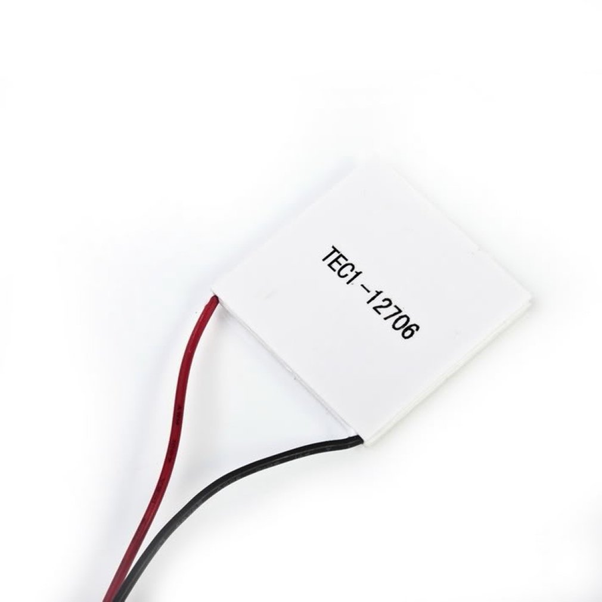

TEC1-12706 Thermoelectric Peltier Module 12V 92W

The TEC1 Peltier module uses 127 semiconductor couples within the the modest area between its two ceramic place to induce a voltage via its namesake effect proportional to the delta between the temperatures of the two plates. With this effect, one can read relative temperature differences, and if the load is light enough (or the delta large enough), power devices.

Being a fully analog device, the pinout here consists only of the negative and positive leads. Safe and consistent use of the module should include placing voltage-limiting circuitry between the module and the remainder of the circuit, as the theoretical application of a lot of sudden head could damage components. Additionally, care should be taken to ensure that voltage is not being fed into the module, else it’ll create a temperature delta on the plates via that supplied voltage.

**Specs[2]**

Operating Voltage 12VDC

Maximum Voltage 15VDC

Maximum Current 6.4A

Maximum Power 92A

Maximum Temperature 138°C

Internal Resistance 1.98Ω

**Scenario I : Pressure Sensor for Construction Accidents**

1. Construction worker is wearing a vest that has several pressure sensors sewn all over.
2. When/If construction material collapses and falls or buries the individual, very bright LEDs will light up.
3. This will make them identifiable by paramedics/emergen



**Scenario II : Pressure Sensor Walking Reward \***

**\*Note**: Based on the assumption that one should walk 10 000 steps for health purposes

1. Individual is wearing pressure sensor sewn in shoes below feet
2. Pressure Sensor reads changes in pressures, and microcontroller uses those values to calculate how many steps the individual has taken.
3. Once the individual has walked 10 000 steps, they will be rewards with a brief foot massage (because there are vibrating motor disks in the shoe).

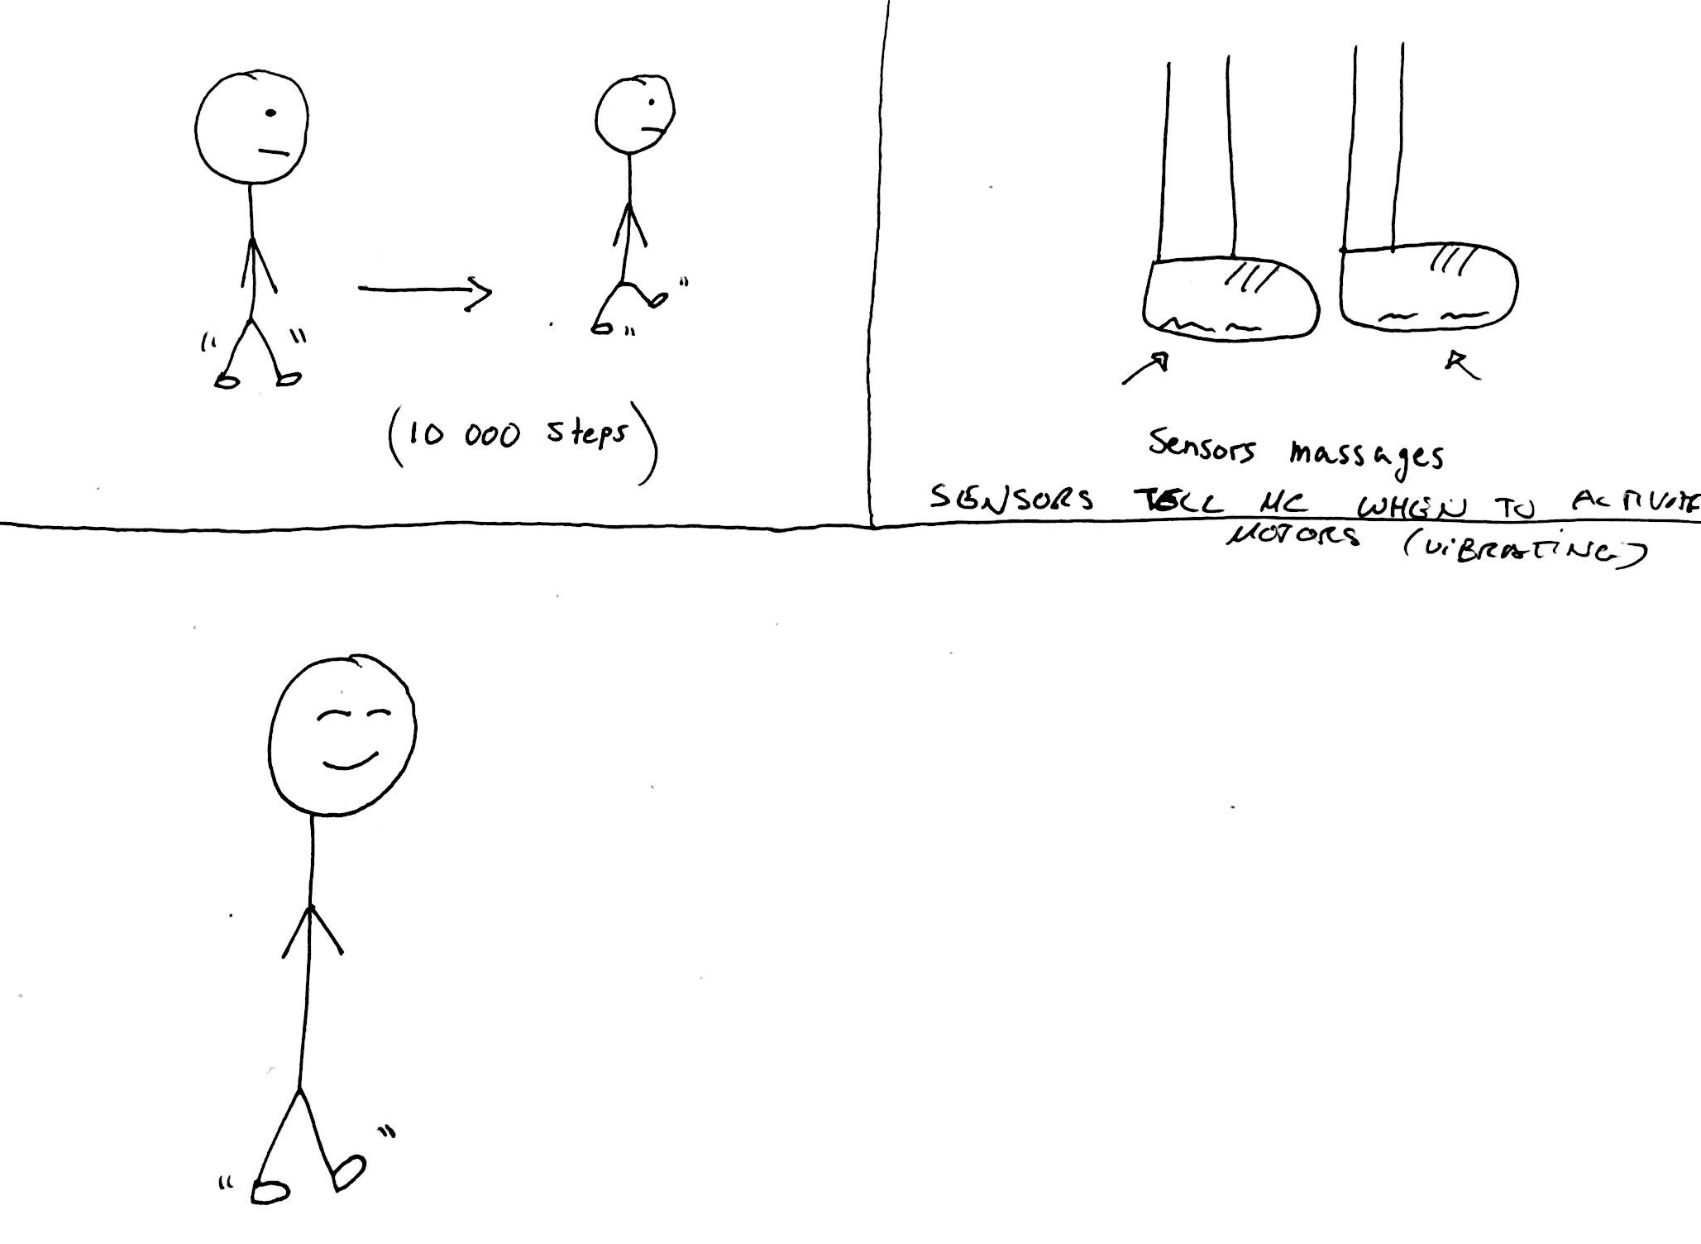

**Scenario III (Final) : “Goldfinger”**

1. Hand with thermoelectric sensor on it is being held and reads changes in temperature increase

2. After certain threshold temperature change causes the speakers to output Goldfinger theme song

3. And also triggers a twitter bot to tweet the number of times “I’ve been warmed today”

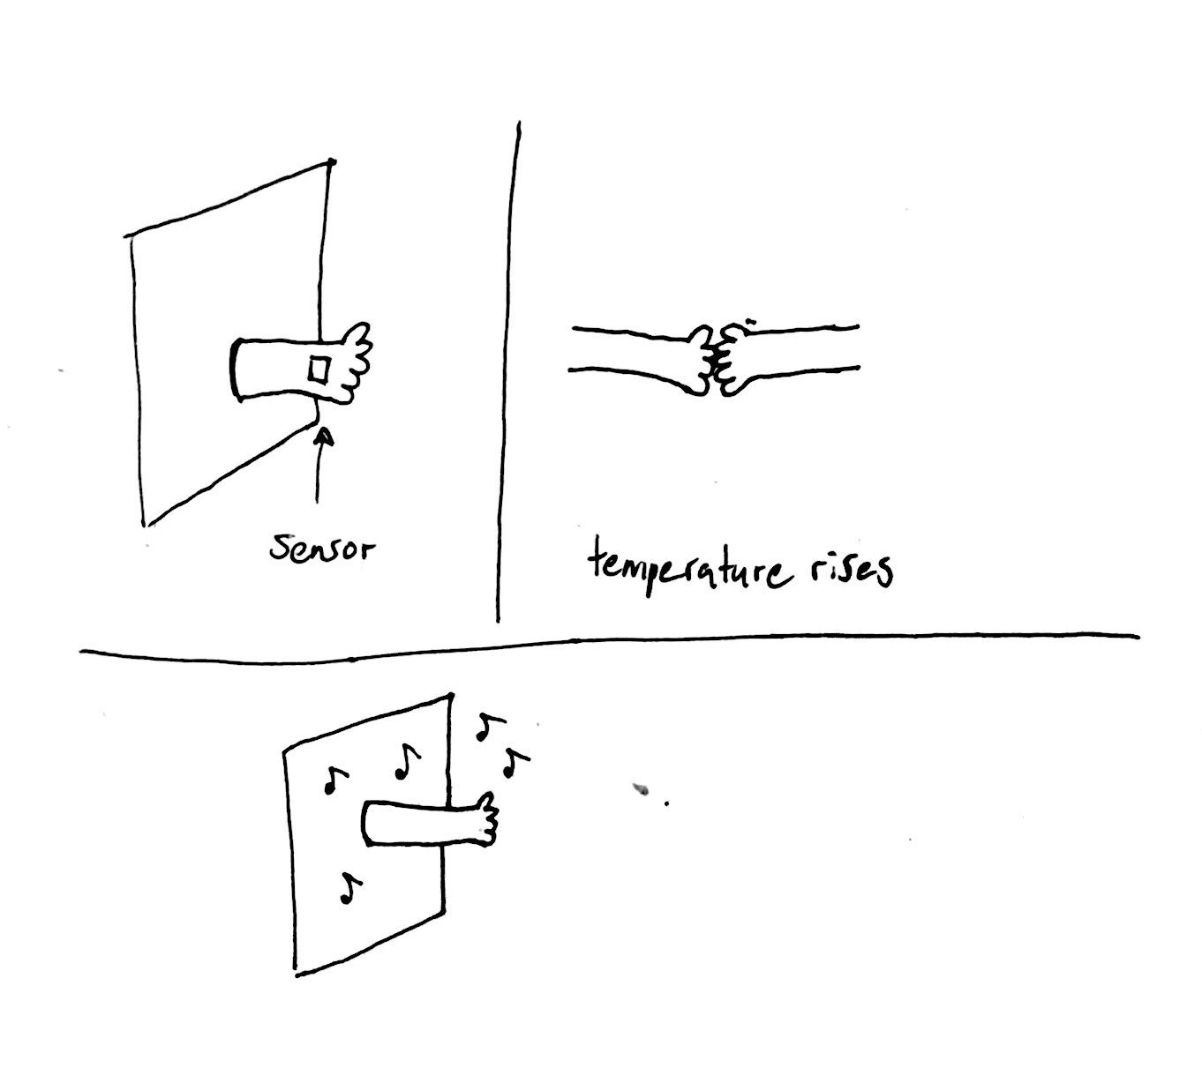

## Part 2: Design description and concept

As a response to “This” assignment we designed a structure that would enable a situated interaction involving an interplay between tangibility, heat and sound.

When hand-holding the wooden hand, the sensor reads heat for a certain period of time. It then determines its being held due to temperature increase by a thermoelectric sensor fixed to the palm of the hand. The nature of this sensor makes it so that the temperature reading will eventually decrease as the temperature differential equalises between the hot and cold side of the sensor. To add, the sensor can only read temperature difference and not absolute. Once it reads the temperature, the nodeMCU (ESP8266) wifi module communicates with the Twitter API to send out a tweet about how many times the hand has been warmed today. If the hand is warm enough, it plays “Goldfinger” theme song of James Bond in piezo pitches.

In the design process we drew from both Midas’ and this particular theme song in order to intrigue the user and then draw an individual by this partially human, otherworldly and inanimate structure that reacts to prolonged tangible interaction. This interaction takes the form of either a handshake or hand-hold. This interaction was meant to be a give and take based interaction, as the story of Midas, from Greek mythology, was his ability to touch anything and turn it into gold. We drew from this myth and wanted to reverse the scenario to a certain extent by allowing the user to “discover” by being the one holding this golden hand.

In addition, we were intrigued by the concept of human telepathy and these “fundamental human desires” (Rose, 174) ( to know what someone else is thinking, and inherently what this hand might be ‘thinking’ and how it will further respond.

We were particularly fascinated by this idea of change in temperature that can occur at different rates. Consequently, somebody with colder hands would have to wait longer to have a reaction whereas somebody with warmer hands would wait a brief amount of time. Additionally, we wanted to invoke curiosity and allow the user to tap into their playful side by testing out the responses of the hand by holding it longer or shorter, thereby allowing the sensor to read the changes in temperature that are occuring, for different amounts of time at once.

As someone holds the hand for an extended length of time, hand reads temperature increase and proceeds to play Shirley Bassey’s James’ Bond *Goldfinger* theme song. We’ve picked the theme because we’re painting the entire structure gold.

## ** Updated Version Description and Concept **

Due to thwarting and unfortunate circumstances we had to shift our project idea slightly. Overall our aim is to create an engaging and playful experience. We wanted to design a community-based intervention which would uplift people’s mood’s for a brief instant. Because of the long and dark working days, we thought of putting into a place a structure that would act as a friendly and inviting “hand” reminding you to keep warm and to take care of one’s self.

The hand would be situated in a public space in busy hectic work environments, such as downtown Montreal. The choice of a fist pump was based on a comment that was made and a triggered realization that handshakes are no longer very common. They have almost become obsolete especially amongst the millennial generation. A handshake also contradicts this idea of warmth and friendliness from an outward reaching hand was intending to accomplish. We wanted to create a playful interaction between an inanimate object and a human being. In other words, have a social intervention. The output of the fistput is a tweet relating to heat which depends on how much time one has left their hand in a “pump” position which would determine how temperature change occurs. We wanted to place this into a winter/Montreal/ downtown context to make the outcome and process relate to one another. The outcome is three different possible tweets:

* Well aren’t you cold?
* Getting warmer…
* It’s warm!

These would be displayed on a small screen suspended above the hand in a public place, as mentioned. Their purpose would be to remind people to keep warm and take care of themselves in a very simple, yet abstract and interactive way.

The fist pump depending on change in temperature (but due to a not very responsive sensor we switched to an FSR to achieve a similar looking effect). Instead of specific ranges of change in pressure, specific force (pressure) value ranges would determine the three states. The lowest pressure triggering the first tweet to send.

## Fritzing/Circuit for FSR & Wifi Shield

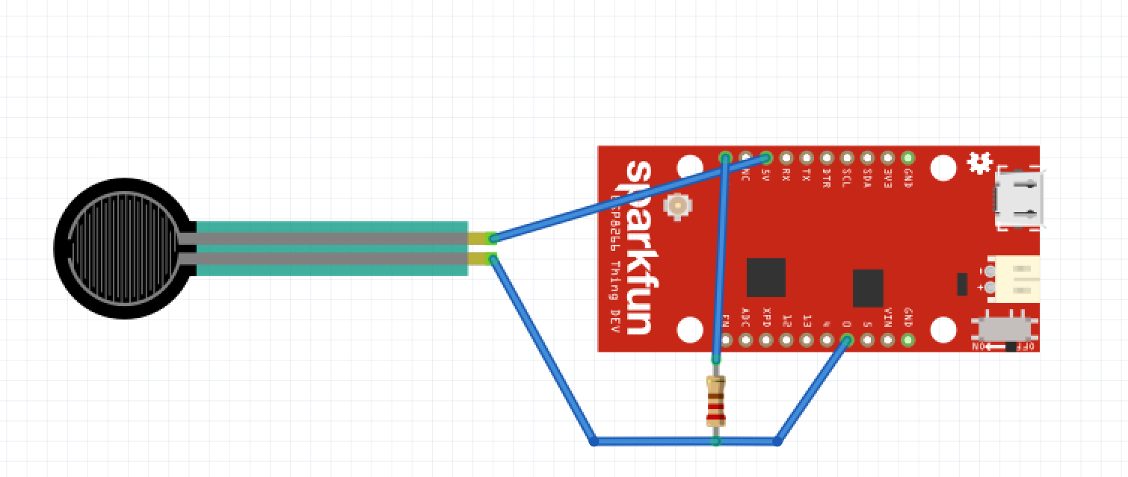

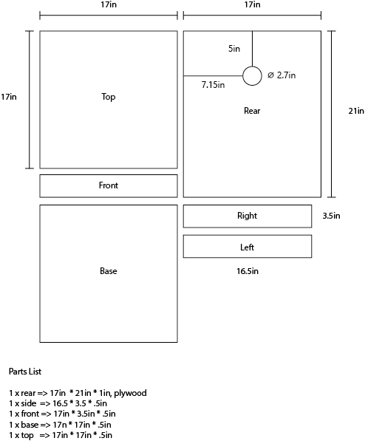

(above) Wooden base blueprint. Final construction assembled with glue and nails.

## Documentation

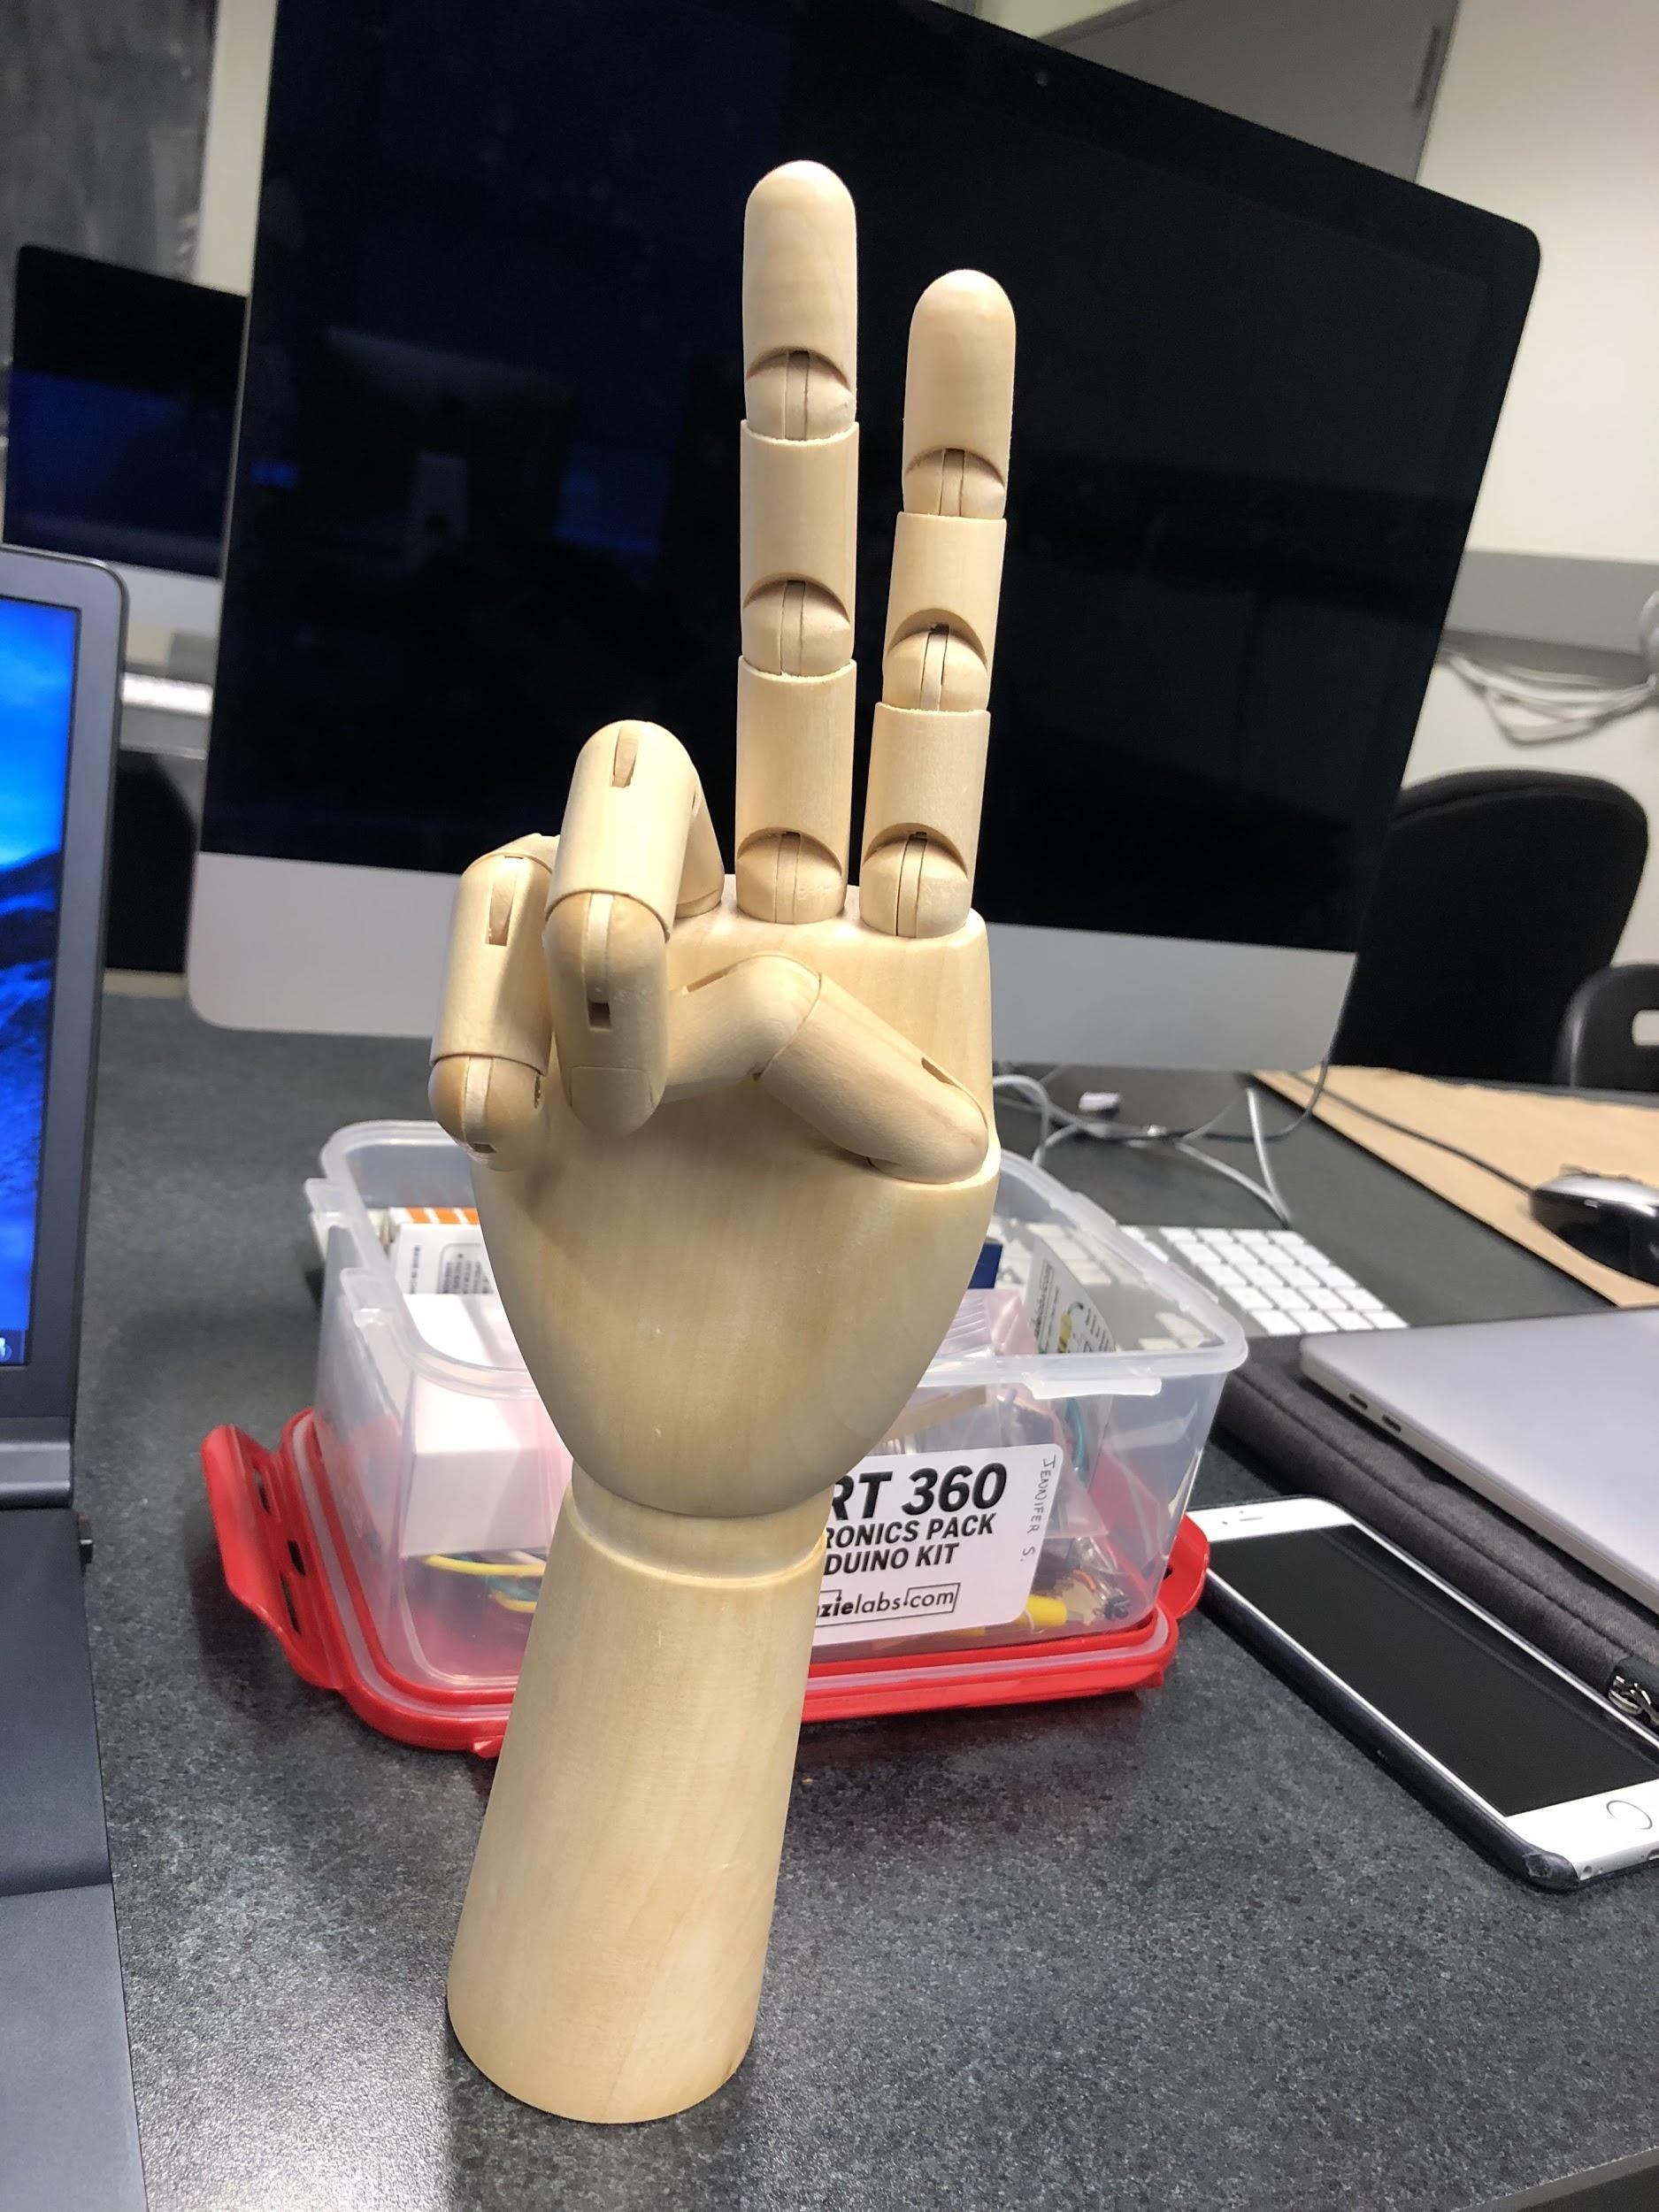

Testing out the sensor with the Arduino Uno. We also added a tiny speaker so that whenever the temperature rises, sound will play faster. As the temperature lowers, sound will play slower until temperature value goes to 0, then there won’t be any noise.

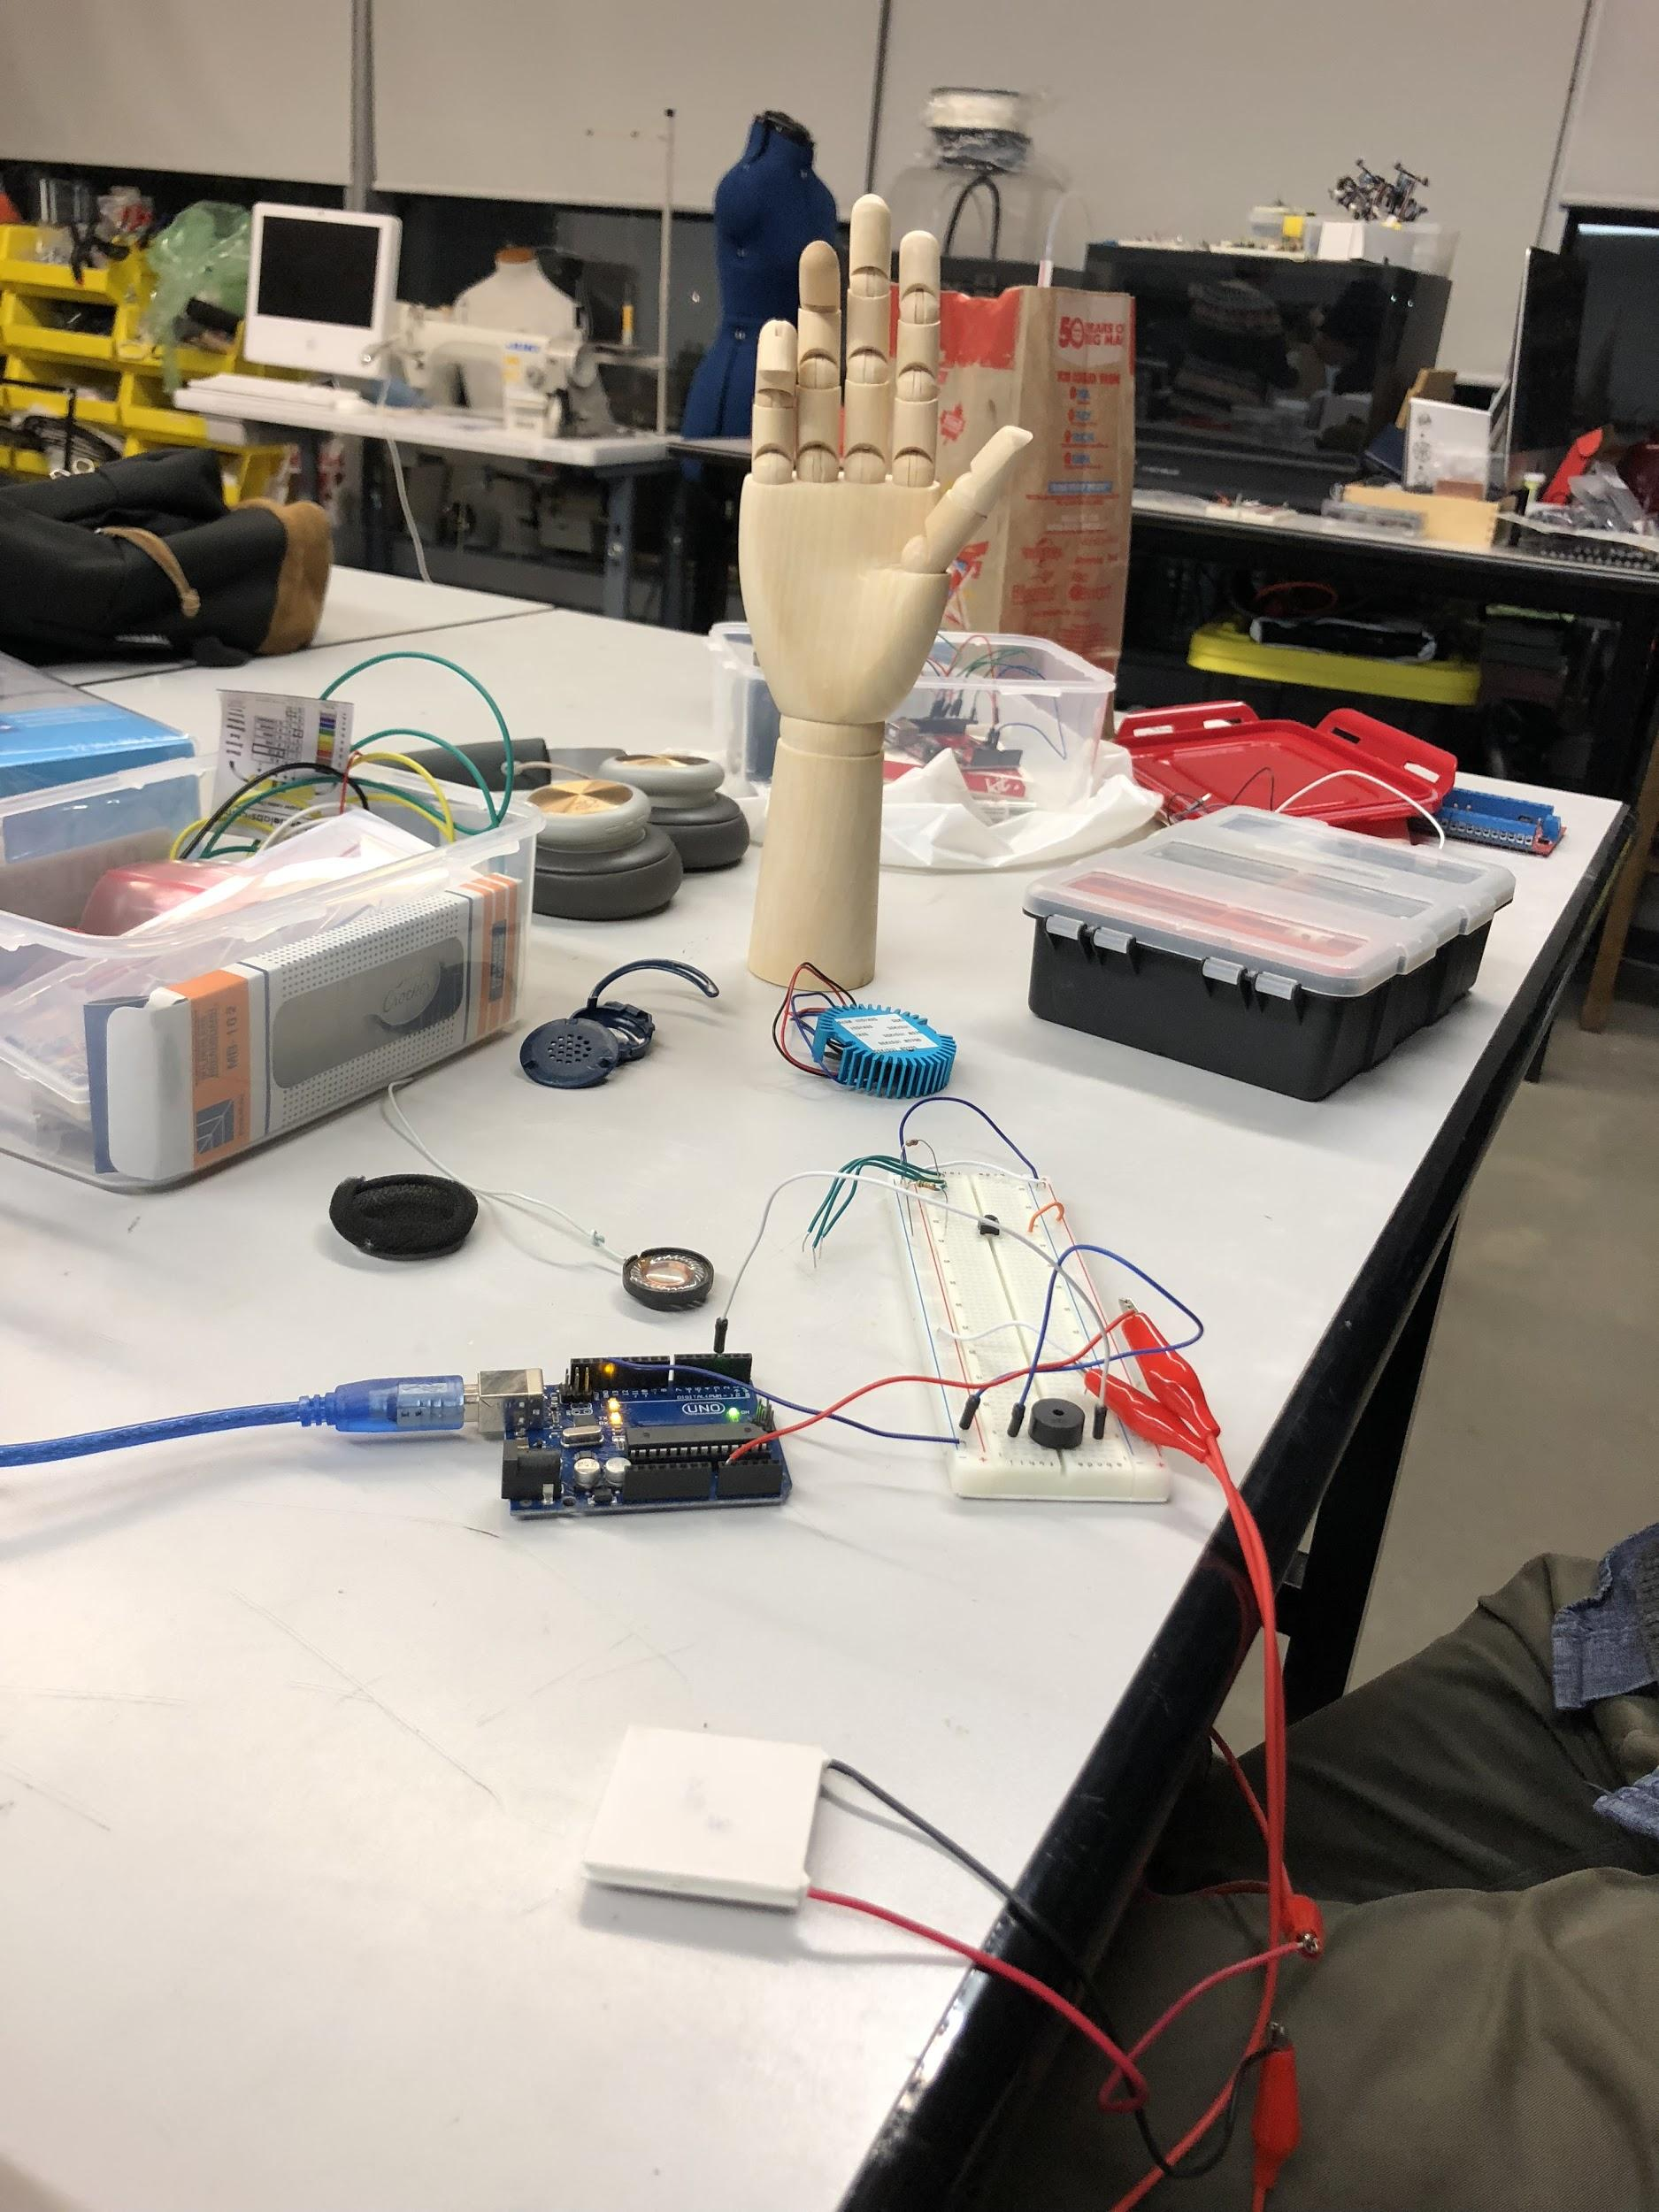

The wooden hand that we are using to place the heat sensor on it.



We wrapped the hand in aluminium foil in order to diffuse the heat.

The wooden structure what would allow us to hand hold horizontally. 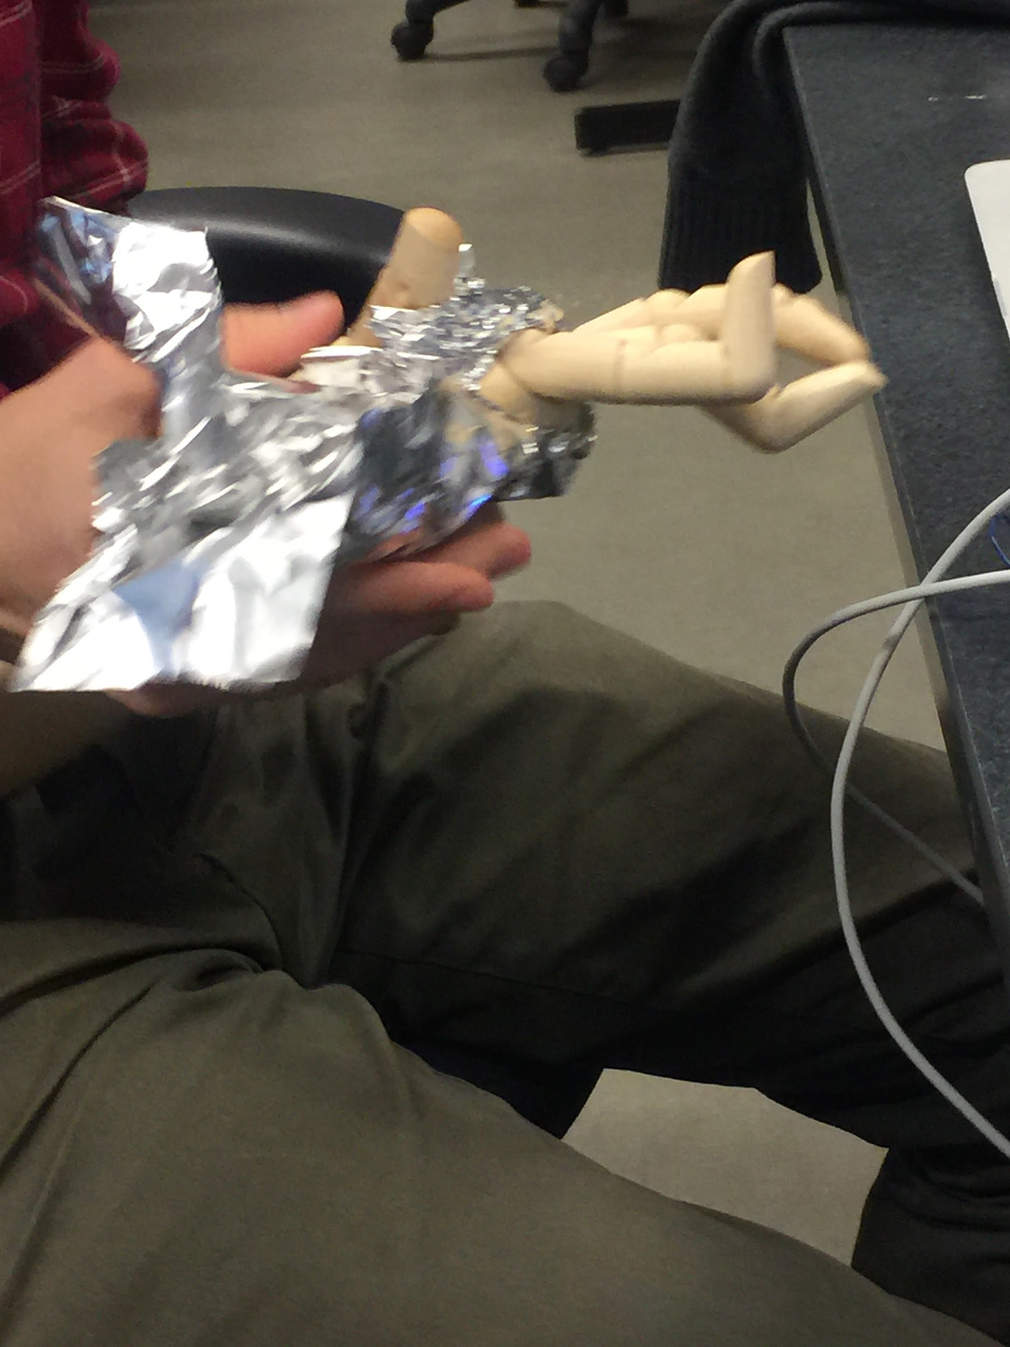

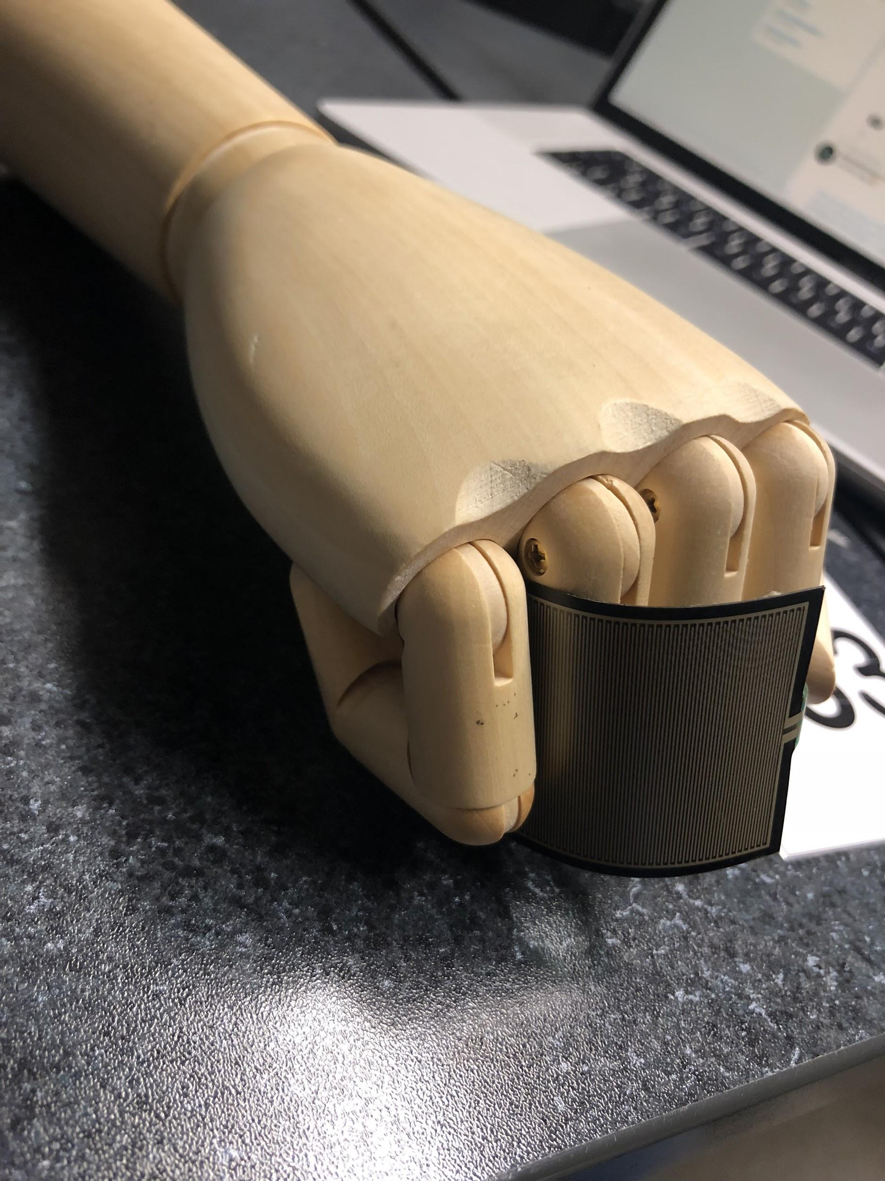

We then slightly changed our idea by using a pressure sensor instead. We also made the hand into a fist form for it to be more welcoming and interactive with the users.

## 

## TEAM MEMBER EVALUATION

**Jennifer**: Team participation was good. Working with Michael helped us get a good idea for out project. We were able to get bunch of ideas together and with him knowing more about this topic, we were able to narrow down to one idea that was doable. Valentine worked great in this project because she was easy to contact with and get answers quickly for when we were both doing the documentation. We both worked on the audio part of the project and figured out what values to put in for the song to work smoothly.

**Valentine**: Overall I believe we worked well as a team, the biggest challenge we encountered was clashing time schedules. Otherwise Michael had prior experience in electronics and knew a bit more about sensors and consequently I think that significantly helped us to steer our project in the right direction. Jennifer was very efficient in gathering all our materials which was paramount to the execution of the project. Additionally she got the sound component of the project running.

**Michael**:

**BIBLIOGRAPHY**

Rose, David. Enchanted Objects: Innovation, Design, and the Future of Technology. Scribner, 2015.

1. <https://thingtype.com/blog/using-an-hpma115s0-air-particles-sensor-with-an-arduino/>
2. <https://robu.in/product/tec1-12706-thermoelectric-peltier-cooler-12-volt-92-watt/>